How to book Breakfast Club

Breakfast Club can only be booked and paid for 24 hours in advance.

Log onto Parentpay website and find your child(ren), under their name(s) click on Pay for other items then below where you pay money in click on make bookings this will take you to the page below.

Click on the box make or view bookings and select dates you need.

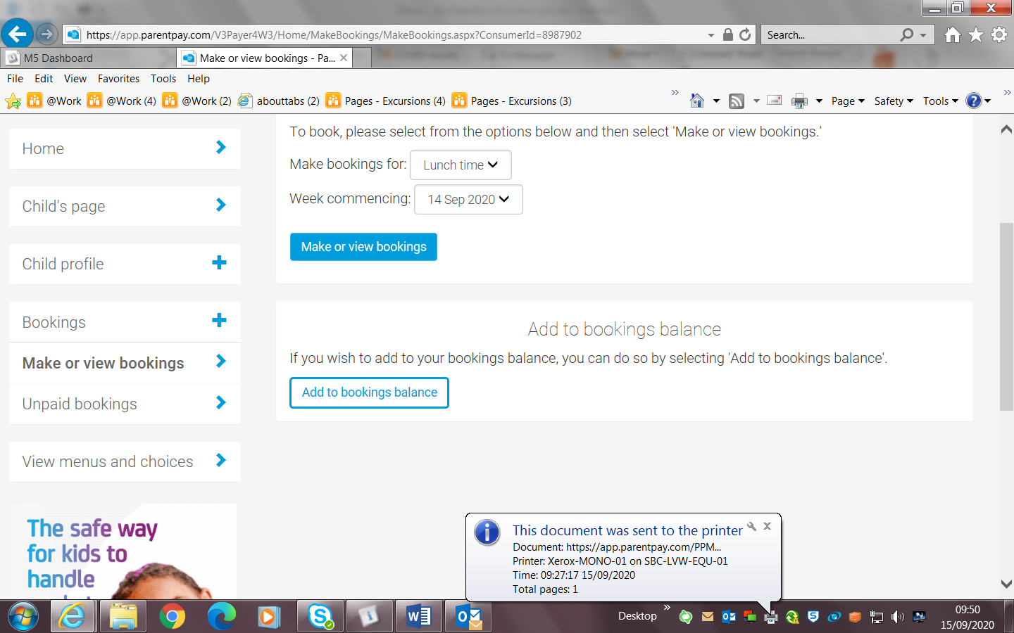
Please remember if you want to book your child(ren) in on a Monday, this must be done by the Friday before 11.00am, so the figures can be given to the canteen.

If you need any help please contact the school. Thank you

